Muslim Identity in Europe and West

Islamophobia: Understanding Anti-Muslim Sentiment in the West
Introduction
A phobia, according to the Merriam-Webster dictionary, is an exaggerated, usually inexplicable and illogical fear of a particular object, class of objects, or situation. It may be hard for the afflicted to sufficiently determine or communicate the source of this fear, but it exists. In recent years, a specific phobia has gripped Western societies - Islamophobia.
Researchers and policy groups define Islamophobia in differing detail, but the term's essence is essentially the same, no matter the source:
An exaggerated fear, hatred, and hostility toward Islam and Muslims that is perpetuated by negative stereotypes resulting in bias, discrimination, and the marginalization and exclusion of Muslims from social, political, and civic life.^{[1]}
Islamophobia existed in premise before the terrorist attacks of September 11, 2001, but it increased in frequency and notoriety during the past decade. The Runnymede Trust in the U.K., for example, identified eight components of Islamophobia in a 1997 report, and then produced a follow-up report in 2004 after 9/11 and the initial years of the Afghanistan and Iraq wars. The second report found the aftermath of the terrorist attacks had made life more difficult for British Muslims.
In a 2011 meeting, the United Nations Alliance of Civilizations, as well as the League of Arab States, a key partner, identified Islamophobia as an important area of concern. Gallup developed a specific set of analyses, based on measurement of public opinions of majority and minority groups in multiple countries, to guide policymakers in their efforts to address the global issue of Islamophobia.
Research shows that the U.S. identified more than 160 Muslim-American terrorist suspects and perpetrators in the decade since 9/11, just a percentage of the thousands of acts of violence that occur in the United States each year. It is from this overall collection of violence that "an efficient system of government prosecution and media coverage brings Muslim-American terrorism suspects to national attention, creating the impression - perhaps unintentionally - that Muslim-American terrorism is more prevalent than it really is." Never mind that since 9/11, the Muslim-American community has helped security and law enforcement officials prevent nearly two of every five al Qaeda terrorist plots threatening the United States^{[2]} and that tips from the Muslim-American community are the largest single source of initial information to authorities about these few plots.^{[3]}
Islamophobia affects more than a small fringe group of Muslims. Through various research vehicles and global polling efforts, Gallup has collected a wealth of data detailing public opinion about various aspects of respect, treatment, and tolerance relative to Muslims worldwide. This brief serves as a snapshot of opinion and thought displayed by people from multiple countries, regions, and communities - findings that chronicle perceptions associated with Islamophobia globally.
Respect and Fair Treatment
Globally, many Muslims report not feeling respected by those in the West. Significant percentages of several Western countries share this sentiment, saying that the West does not respect Muslim societies. Specifically, 52% of Americans and 48% of Canadians say the West does not respect Muslim societies. Smaller percentages of Italian, French, German, and British respondents agree.
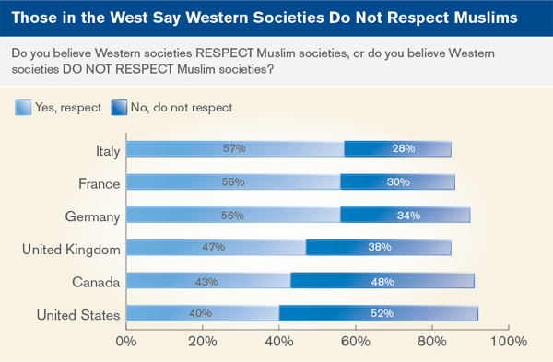Data reported from 2011^{[4]}
Looking specifically at data from the U.S., U.K., France, and Germany, opinions about respect in the West for Muslim societies generally stayed consistent from 2008 to 2011, aside from a 9-percentage-point decrease among Germans.
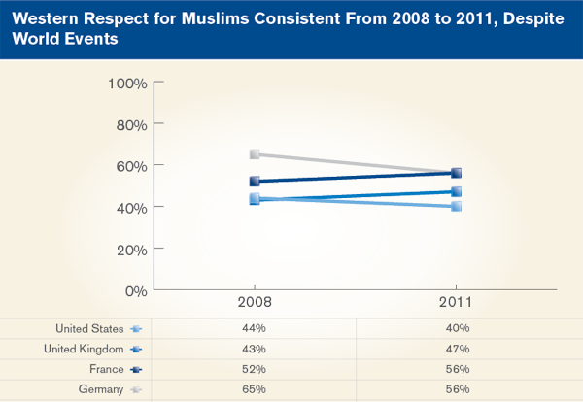Data reported from 2008 and 2011^{[5]}
Several elements can affect the interactions and degree of respect between Muslim and Western societies. Differences in culture, religion, and political interests may shape one population's opinion toward the other. Definitions of Islamophobia tend to attribute fear or hatred of Muslims to their politics or culture, and to Islam and the religiosity of Muslims.
When asked where they think tensions between the Muslim and Western worlds originate, answers vary. Those in Middle East and North Africa (MENA) nations and in the U.S. and Canada equally cite religion and political interests as the primary cause of tensions. Sub-Saharan Africans more often cite religion than politics, while Europeans say political interests are the driving force behind Muslim-West tensions.
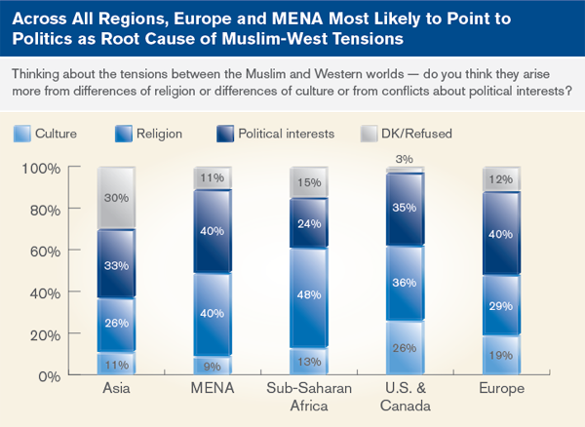Data reported from 2008^{[6]}
Religion and culture outpace politics across all regions surveyed as the root cause of tension between Muslim and Western worlds. This is significant in discussions about Islamophobia, considering political interests can vary and change while cultural and religious differences are more ingrained within populations.
Recent examples of Islamophobia exist within several countries. In late 2009, the largest party in the Swiss parliament put to referendum a ban on minaret construction. The government opposed the ban, citing harm to the country's image - and particularly Muslims' views of Switzerland. Nearly 60% of Swiss voters and 22 out of 26 voting districts voted in favor of the ban, leading to cries of Islamophobia by leaders in countries such as Pakistan and organizations such as the United Nations.
In the month following the referendum, Gallup asked a representative sample of Swiss adults a series of questions about the issue specifically and Muslim rights in general. Most Swiss say that religious freedom is important for Swiss identity. About one-third agree that there is an irresolvable contradiction between liberal democracy and Islam. However, the Swiss are more likely to disagree (48%) than agree (38%) with that statement. Rather, 84% say it is possible for a Muslim to be a good Swiss patriot. When asked if those in the Swiss Muslim community have reason to believe they have been discriminated against in the wake of the minaret ban, two-thirds (68%) say no. Furthermore, most Swiss say they do not believe that the recent belief that Switzerland was being seen as willing to infringe on the rights of its Muslim minority in the wake of the referendum on minarets has harmed Switzerland's reputation in the international community.
Despite a very public debate on the banning of a religious symbol of Islam, much of the Swiss population did not believe that the Swiss Muslim community should feel discriminated against.

